April - December 2024 Safety, Health & Environmental Services and Events
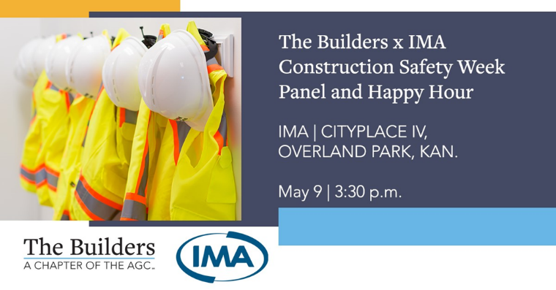
Join The Builders as we co-host a Construction Safety Week panel and happy hour with IMA. Enjoy IMA's newly renovated outdoor space for a panel with construction professionals as they discuss managing the construction industry Labor Shortage challenge. A happy hour will follow in the courtyard with cold drinks and light appetizers while networking with industry peers to celebrate Construction Safety Week 2024.
Panelists:
Moderated by Caleb Weir, IMA
Don Campbell, P1 Group, Inc.
Angela Cloud, McCownGordon Construction
Matt Dierking, The Builders, a chapter of the AGC
Marcus Reiter, IMA
WHERE: IMA | 11350 Switzer Road, Suite 200 Overland Park, KS 66210
COST: FREE, but you must register.

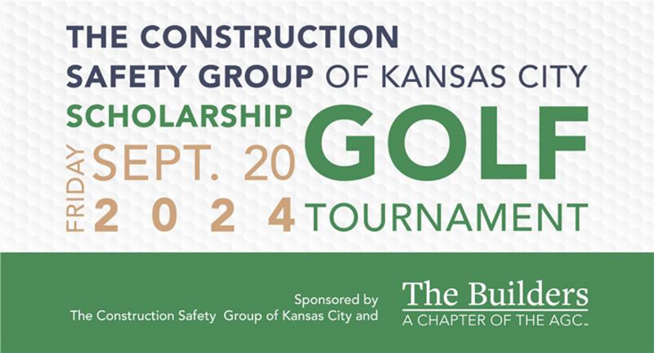
The Construction Safety Group (CSG) of Kansas City is excited to announce the return of its annual scholarship golf tournament at Shoal Creek Golf Course on Sept. 20, 2024. Proceeds from the tournament will support students majoring in occupational safety, health, and environmental studies at Pittsburg State University and the University of Central Missouri. Registration details will be released soon. Be sure to check back here for updates!

OSHA Silica Competent Person Course
Description: The purpose of this course is to educate course participants about OSHA’s Crystalline Silica Standard in the Construction Industry and provide an understanding of the hazards of respirable crystalline silica and appropriate ways to limit exposure. A key component in preventing overexposure to silica and subsequent disease is to have at least one individual on the jobsite who can recognize and evaluate situations where over exposure may be occurring; who knows how to evaluate the exposure potential; and who can make an initial recommendation on how to control that exposure. This is the role of the “Silica Competent Person.” OSHA 29 CFR 1926.1153 requires each employer to have a “Silica Competent Person” who can identify existing and foreseeable respirable crystalline silica hazards.
Knowledge check: A written multiple-choice learning exercise is administered at the conclusion of the course.
Course completion documentation: Upon successful course completion, each participant will receive a photo ID data card from The Builders, a chapter of the AGC.

Location | Member | Nonmember
OAK, BAS, BAJ | $100.00 | $150.00

OSHA is fully enforcing the silica standard in construction. The Builders, a chapter of the AGC SH&E team can assist your organization comply with all the requirements of OSHA’s silica in construction standard, including company specific silica exposure control plans (ECP) and silica air sampling. For more information, please contact Matt Dierking at 816.595.4158 or mdierking@thebuildersagc.com.

OSHA Fall Protection Course
Description: OSHA standards require employers to provide fall protection training for each employee who might be exposed to fall hazards. The training shall enable employees to recognize the hazards of falling and shall train each employee in the procedures to be followed to minimize these hazards. This Fall Protection Course includes but is not limited to: establishing definitive parts of Personal Fall Arrest Systems (including body supports, lanyards, self-retracting lifelines, rope grabs, and anchorage components), anchorage points (determination and suitability), arresting forces (limits, methods to reduce, etc.), and fall distances (limits, deceleration distances). This course also covers the usage of equipment including ladder climbing systems, horizontal lifeline systems, rescue and retrieval systems, rope grab systems, self-retracting lifelines and care/maintenance of fall protection equipment upon request.
Knowledge check: A written multiple-choice learning exercise is administered at the conclusion of the course.
Course completion documentation: Upon successful course completion, each participant will receive a photo ID data card from The Builders, a chapter of the AGC.

Location | Member | Nonmember
OAK, BAS, BAJ | $100.00 | $150.00

OSHA’s fall protection standard is currently the first most frequently cited OSHA violation.

OSHA Hazard Communication Standard Course
Description: OSHA standards require employers to provide exposed employees with effective information and training on hazardous chemicals in their work area at the time of their initial assignment, and whenever a new chemical hazard the employees have not previously been trained about is introduced into their work area. This course covers the general requirements of OSHA’s Hazard Communication Standard and provides participants with the knowledge to facilitate recognition and understanding of chemical safety in the workplace. Specific topics covered in this course include hazard classification of health and physical hazards, chemical labeling, signal words, GHS Symbols (Pictograms), Safety Data Sheets (SDSs) 16 –section format and much more.
Knowledge check: A written multiple-choice learning exercise is administered at the conclusion of the course.
Course completion documentation: Upon successful course completion, each participant will receive a photo ID data card from The Builders, a chapter of the AGC.

Location | Member | Nonmember
OAK, BAS, BAJ | $100.00 | $150.00

OSHA’s hazard communication standard is currently the second most frequently cited OSHA violation.

OSHA Scaffolding Course
Description: This course covers the requirements for safe construction and use of scaffolding using OSHA’s construction scaffold standards as a guide. OSHA standards require employers to train each employee who performs work while on a scaffold trained to recognize the hazards associated with the type of scaffold being used and to understand the procedures to control or minimize those hazards. Course topics include hazards associated with scaffold design, assembly, disassembly and use, types of scaffolds, determining scaffold capacity, employee qualifications and training and maintenance, repair and inspection requirements.
Knowledge check: A written multiple-choice learning exercise is administered at the conclusion of the course.
Course completion documentation: Upon successful course completion, each participant will receive a photo ID data card from The Builders, a chapter of the AGC.

Location | Member | Nonmember
OAK, BAS, BAJ | $100.00 | $150.00

OSHA’s scaffolding standard is currently the third most frequently cited OSHA violation.

OSHA Forklift Operator Course
Description: This course has been designed to reduce injuries and property damage in the work environment for newly trained operators who are ready to go beyond the basics to experienced operators who are either new to your organization or have been with your organization for an extended period. Course topics include inspection of equipment, design criteria of the equipment, picking up the load, moving the load and setting down the load safely.
Knowledge check: A written multiple-choice learning exercise and Operator Performance Evaluation is administered at the conclusion of the course.
Course completion documentation: Upon successful course completion, each participant will receive a photo ID data card from The Builders, a chapter of the AGC.

Location | Member | Nonmember
OAK, BAS, BAJ | $100.00 | $150.00

OSHA’s powered industrial truck standard is currently the seventh most frequently cited OSHA violation.

OSHA 10-Hour Construction Outreach Course
Description: The OSHA 10-Hour Construction Outreach Course provides safety and health training to prepare employees for basic hazards found in the construction industry. Participants will gain an understanding of OSHA’s Construction Safety and Health Regulations as they apply to real world experiences. Each participant will receive a 29 CFR 1926 Construction Standards Book. Upon successful course completion, each participant will also receive a photo ID data card from The Builders, a chapter of the AGC and a U.S. Department of Labor (OSHA) 10-Hour Construction Outreach completion card.
Missouri House Bill 1549 - This course meets the requirements of HB 1549 that became effective on Aug. 28, 2009, requiring all on-site employees for contractors or subcontractors working on “Public Works” construction projects in which the contract or subcontract is signed on or after Aug. 28, 2009, to have completed an OSHA 10-Hour construction safety program or equivalent within sixty (60) days of beginning work.

Location | Member | Nonmember
OAK, BAS, BAJ | $150.00 | $275.00

OSHA 30-Hour Construction Outreach Course
Description: The OSHA 30-Hour Construction Outreach Course is an excellent course for superintendents, field supervisors, project managers, safety professionals, or anyone responsible for safety and health issues in your organization. Attendees will gain an understanding of OSHA Construction Safety Regulations as they apply to real world experiences. Each participant will receive a 29 CFR 1926 Construction Standards Book. Upon successful course completion, each participant will also receive a photo ID data card from The Builders, a chapter of the AGC and a U.S. Department of Labor (OSHA) 30-Hour Construction Outreach completion card. Participants must attend all dates to receive a course completion card. Lunch will be provided.

Location | Member | Nonmember
OAK, BAS, BAJ | $425.00 | $550.00

American Red Cross Workplace First Aid/AED/CPR Course
Description: The purpose of this course is to give individuals in the workplace knowledge and skills necessary to recognize and provide basic first aid care for injuries and sudden illnesses until advanced medical personnel arrive and take over. This course also includes information on breathing or cardiac emergencies. Please wear comfortable clothing, as you will be asked to perform skills. Attendance of the entire session is required, and participants must complete all skill practices for certification. Upon successful course completion, each participant will receive an American Red Cross Universal Certificate indicating First Aid/AED/CPR that is valid for two years.

Location | Member | Nonmember
OAK, BAS, BAJ | $125.00 | $175.00

OSHA Confined Space Entry for Construction Course
Description: This course covers the safety and health hazards associated with confined spaces in the construction industry. Course topics include recognition of confined space hazards, identification of permit required confined spaces (PRCS) and non-permit required confined spaces (NPRCS), use of instrumentation to evaluate atmospheric hazards, ventilation techniques, development and implementation of a confined space program, proper signage and training requirements. This course also covers the key differences between OSHA’s general industry versus construction standards.
Knowledge check: A written multiple-choice learning exercise is administered at the conclusion of the course.
Course completion documentation: Upon successful course completion, each participant will receive a photo ID data card from The Builders, a chapter of the AGC.

Location | Member | Nonmember
OAK, BAS, BAJ | $100.00 | $125.00

OSHA Excavation Competent Person Course
Description: This course has been designed specifically for those involved in excavation, trenching, and related operations. OSHA requires a “Competent Person” to oversee these jobsites, as they are some of the most hazardous of all construction operations. Topics covered in this course include:
- 29 CFR 1926, Subpart P  - OSHA excavation competent person  - Inspection  - Soil classification categories  - Fall protection  - Protective systems  - Access and egress  - Exposure to falling loads  - Exposure to vehicular traffic | - Water accumulation  - Identification of underground utilities and one call system  - Hazardous atmospheres  - Emergency rescue planning  - Criminal prosecution and wrongful death lawsuits relating to trenching/excavation accidents
Knowledge check: A written multiple-choice learning exercise is administered at the conclusion of the course.
Course completion documentation: Upon successful course completion, each participant will receive a photo ID data card from The Builders, a chapter of the AGC.

Location | Member | Nonmember
OAK, BAS, BAJ | $100.00 | $125.00

OSHA Focus Four Hazard Course
Description: This course focuses on the top four hazards in the construction industry (falls, electrocutions, struck-bys and caught-ins). Construction workers make up approximately 6% of the country’s workforce, but account for more than 20% of all job-related fatalities each year. Construction is one of the most hazardous industries in America; each year a substantial number of construction workers, and countless others, are injured by these four hazards. Participants will be introduced to accident prevention techniques and hazard recognition to improve their awareness about the focus four hazards and ways to abate these hazards. Upon successful course completion, each participant will receive a photo ID data card from The Builders, a chapter of the AGC.

Location | Member | Nonmember
OAK, BAS, BAJ | $100.00 | $125.00

For additional information about any of these courses, multiple participant discount pricing or to schedule a course specifically for your organization contact:
Matt Dierking at 816.595.4158 or mdierking@thebuildersagc.com.

Course registration information
- Course cancellations/confirmations will be made via email, with the designated contact person listed on the registration, the week prior to scheduled course date.
- Course cancellation must be made a minimum of five (5) business days prior to the scheduled course date to receive a full course refund or to reschedule.
- Each scheduled course is required to have a minimum enrollment of eight (8) paid course participants for the course to be conducted.
- Any course participant who has been ill or has any signs of illness within twenty-four (24) hours prior to the class (fever, cough, breathing difficulties/shortness of breath, or other symptoms) should not attend a course.

Course footnotes
1No charge to attend course for Carpenters, Millwrights, and Floorlayers in good standing with the St. Louis - Kansas City Carpenters Regional Council. The Builders, a chapter of the AGC reserves the right to charge for course fees if denied by CDC.

Location of training courses
OAK: The Builders, a chapter of the AGC, 720 Oak St., Kansas City, MO 64106
BAS: The Builders, a chapter of the AGC, Southern Service Center, 521 South Ingram Mill Road, Springfield, MO 65802
BAJ: The Builders, a chapter of the AGC, Central Service Center, 3632 West Truman Blvd., Jefferson City, MO 65109
To have training conducted at your facility or at a specific location, please contact Matt Dierking at 816.595.4158 or mdierking@thebuildersagc.com.
To register, please complete the registration form on the next page. Return the form along with a check payable to The Builders, a chapter of the AGC to:
The Builders, a chapter of the AGC
Attn: Morgan Morrison
720 Oak Street
Kansas City, MO 64106
Contact Morgan Morrison at 816.595.4130 or mmorrison@thebuildersagc.com should you have questions.

Registration form
To make reservations for a course, complete the following information: (Please type or print)
Company name: Click or tap here to enter text.
Company address: Click or tap here to enter text. | Contact person: Click or tap here to enter text.
Telephone number: Click or tap here to enter text. | Email: Click or tap here to enter text.
Course title: Click or tap here to enter text.
Select location: Choose an item.
Participant’s name(s): Click or tap here to enter text.
Total member participants: Choose an item. | Total nonmember participants: Choose an item.
Amount of check: $Click or tap here to enter text.
☐Check box if you are a member of the St. Louis-Kansas City Carpenters Regional Council.

